IEGIS 1st Annual ScavEnger Hunt  - July 11th at ESRI UC 17  Join Us:  Join us for a Scavenger Hunt and IEGIS social at ESRI UC 17.  Details:  - Scavenger hunt goes active at 3:00pm and ends at 6:00pm  - Social at Quad Ale House 6:30 – 8:30*  - Drawings start at 7:00pm – For more Information RSVP  *Note, Food and Beverage not hosted.  RSVP here  Sponsors:  - Miller Spatial  - SEDARU  - EVARI GIS Consultining  - Geocortex  - Michael Baker  - Infor  - Nobel Systems  - SoCal URISA  - Muni Gov Guy  - PSOMAS  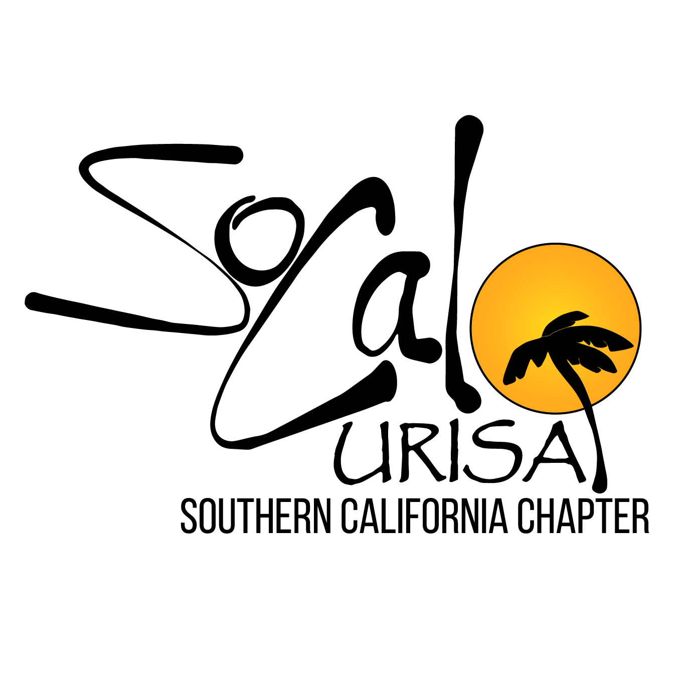  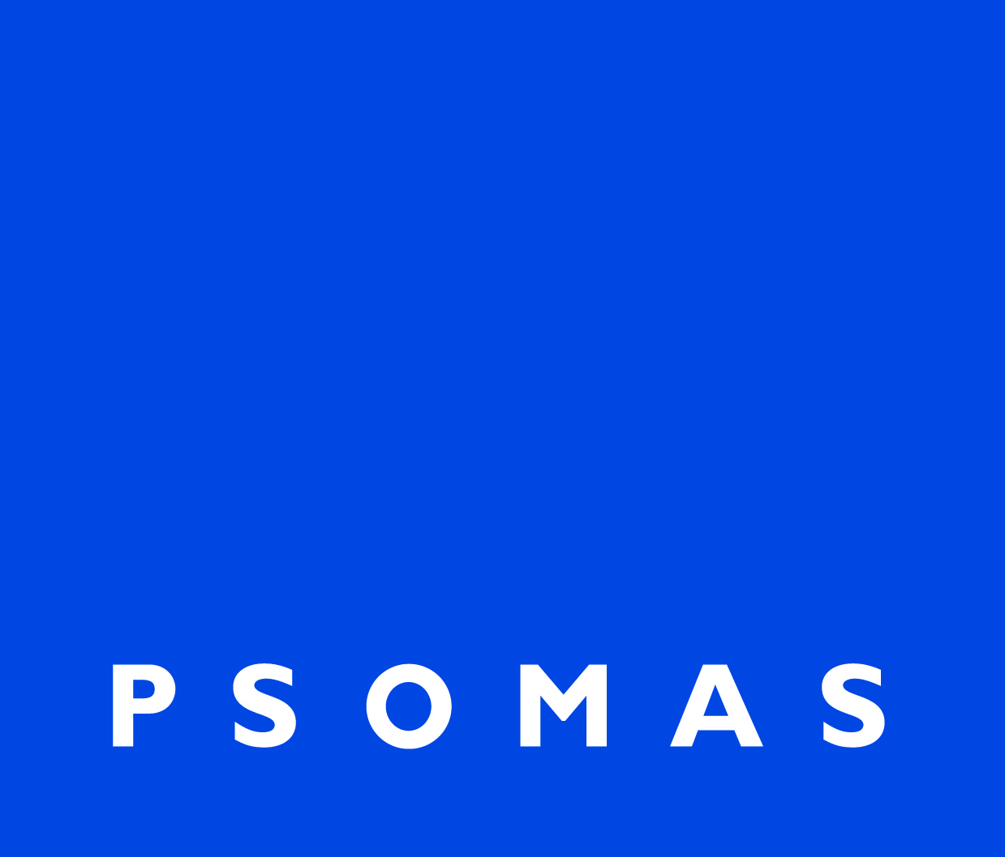 | Where: San Diego  When: Tuesday July 11th, 2017  Time:  Scavenger Hunt: 3:00 – 6:00  Social starting at 6:30  @  Quad Ale House  868 Fifth Ave, San Diego, CA 92101

